

Course Code: CBS3005
Course Title: Cloud, Microservices and Applications
Class Number: VL2025260105679
Lab Assessment - 2
Name: Atharva Khachane
Reg No: 22BBS0155

Question:
Create a simple web application using your preferred programming language and framework (e.g., Node.js, Python, Java etc.). Ensure the application is fully functional and ready for deployment. Initialize an AWS Elastic Beanstalk environment for your application. Choose the appropriate platform (e.g., Node.js, Python, Java) and configure the environment settings. Package your web application and deploy it to the Elastic Beanstalk environment. Access the deployed web application via the Elastic Beanstalk URL provided. Test its functionality to confirm that the deployment was successful and that the application is accessible and performs as expected.

Node Application Creation:
Initialize node application and download express
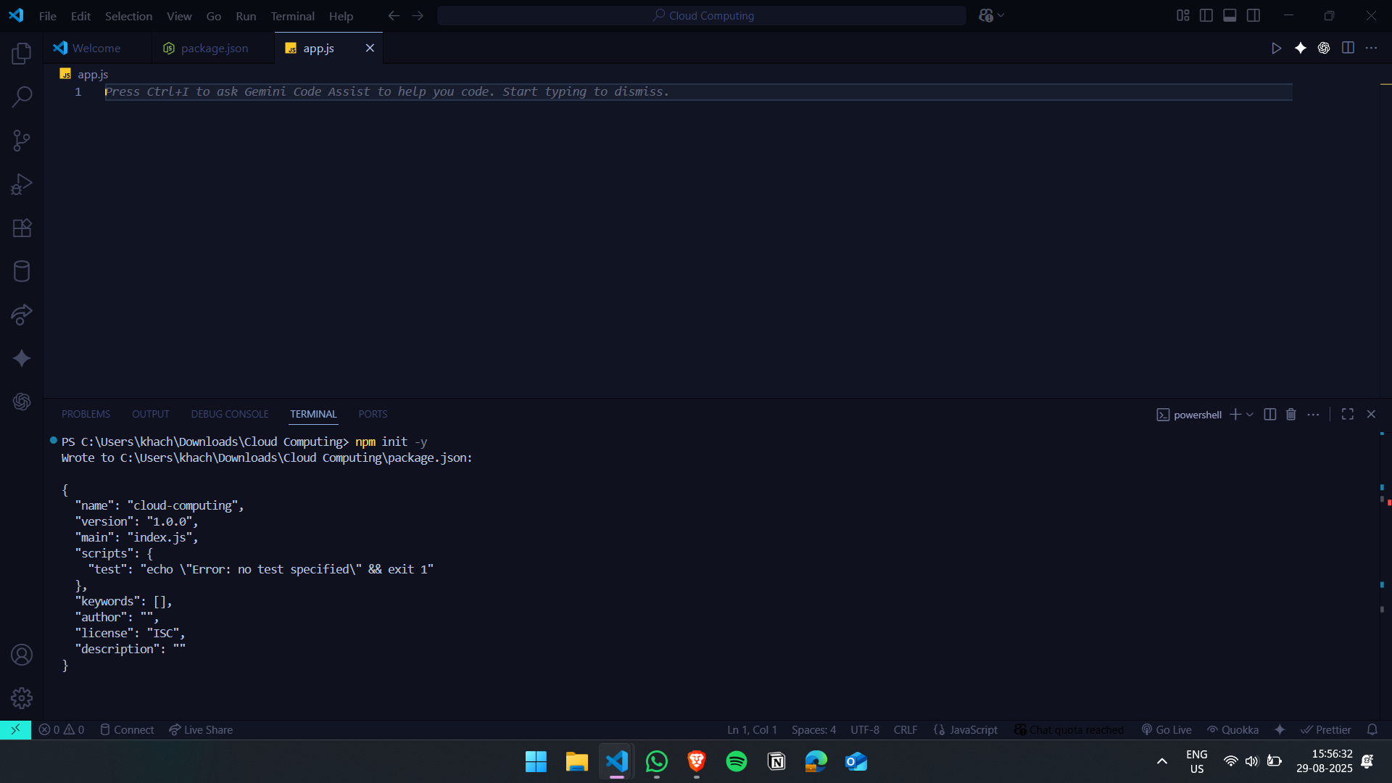
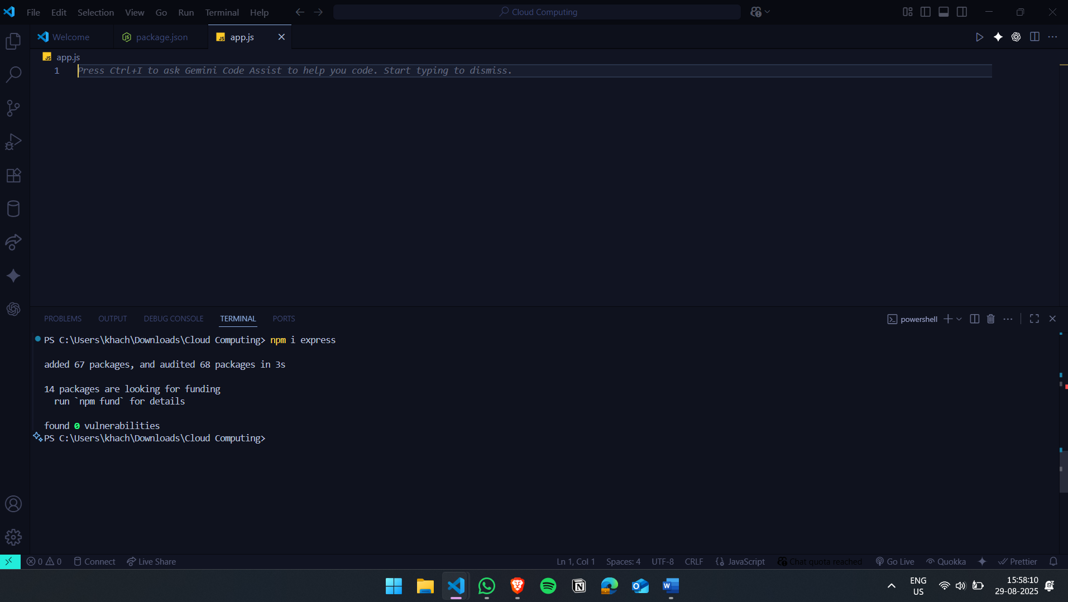

Create application.
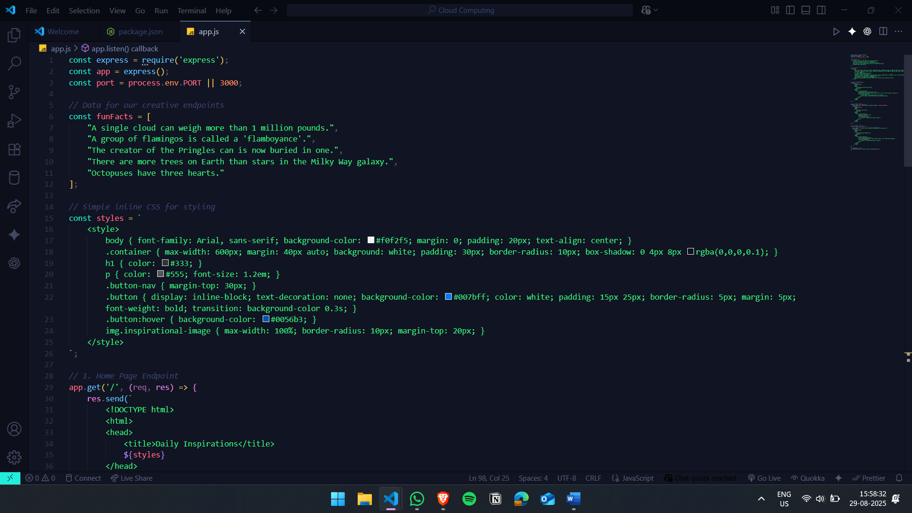

Create a zip of the files app.js, package.json and package-lock.json
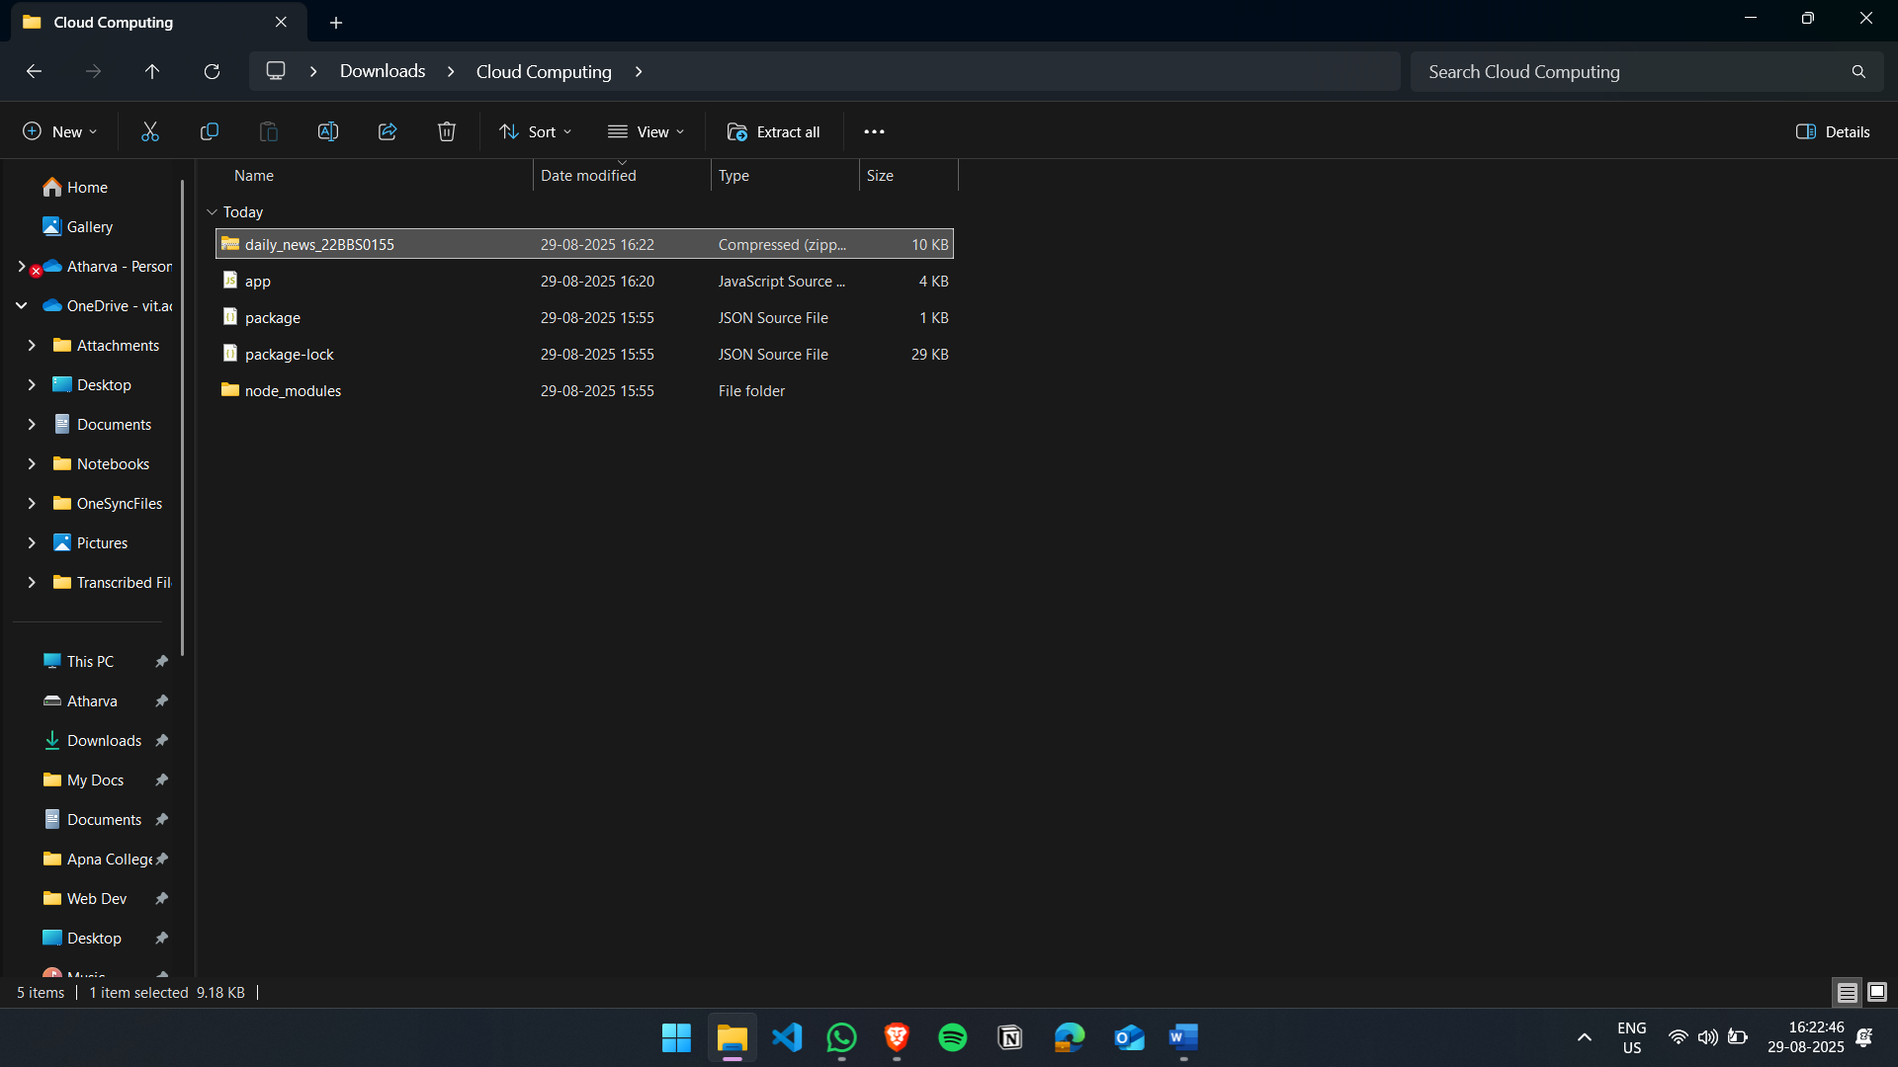

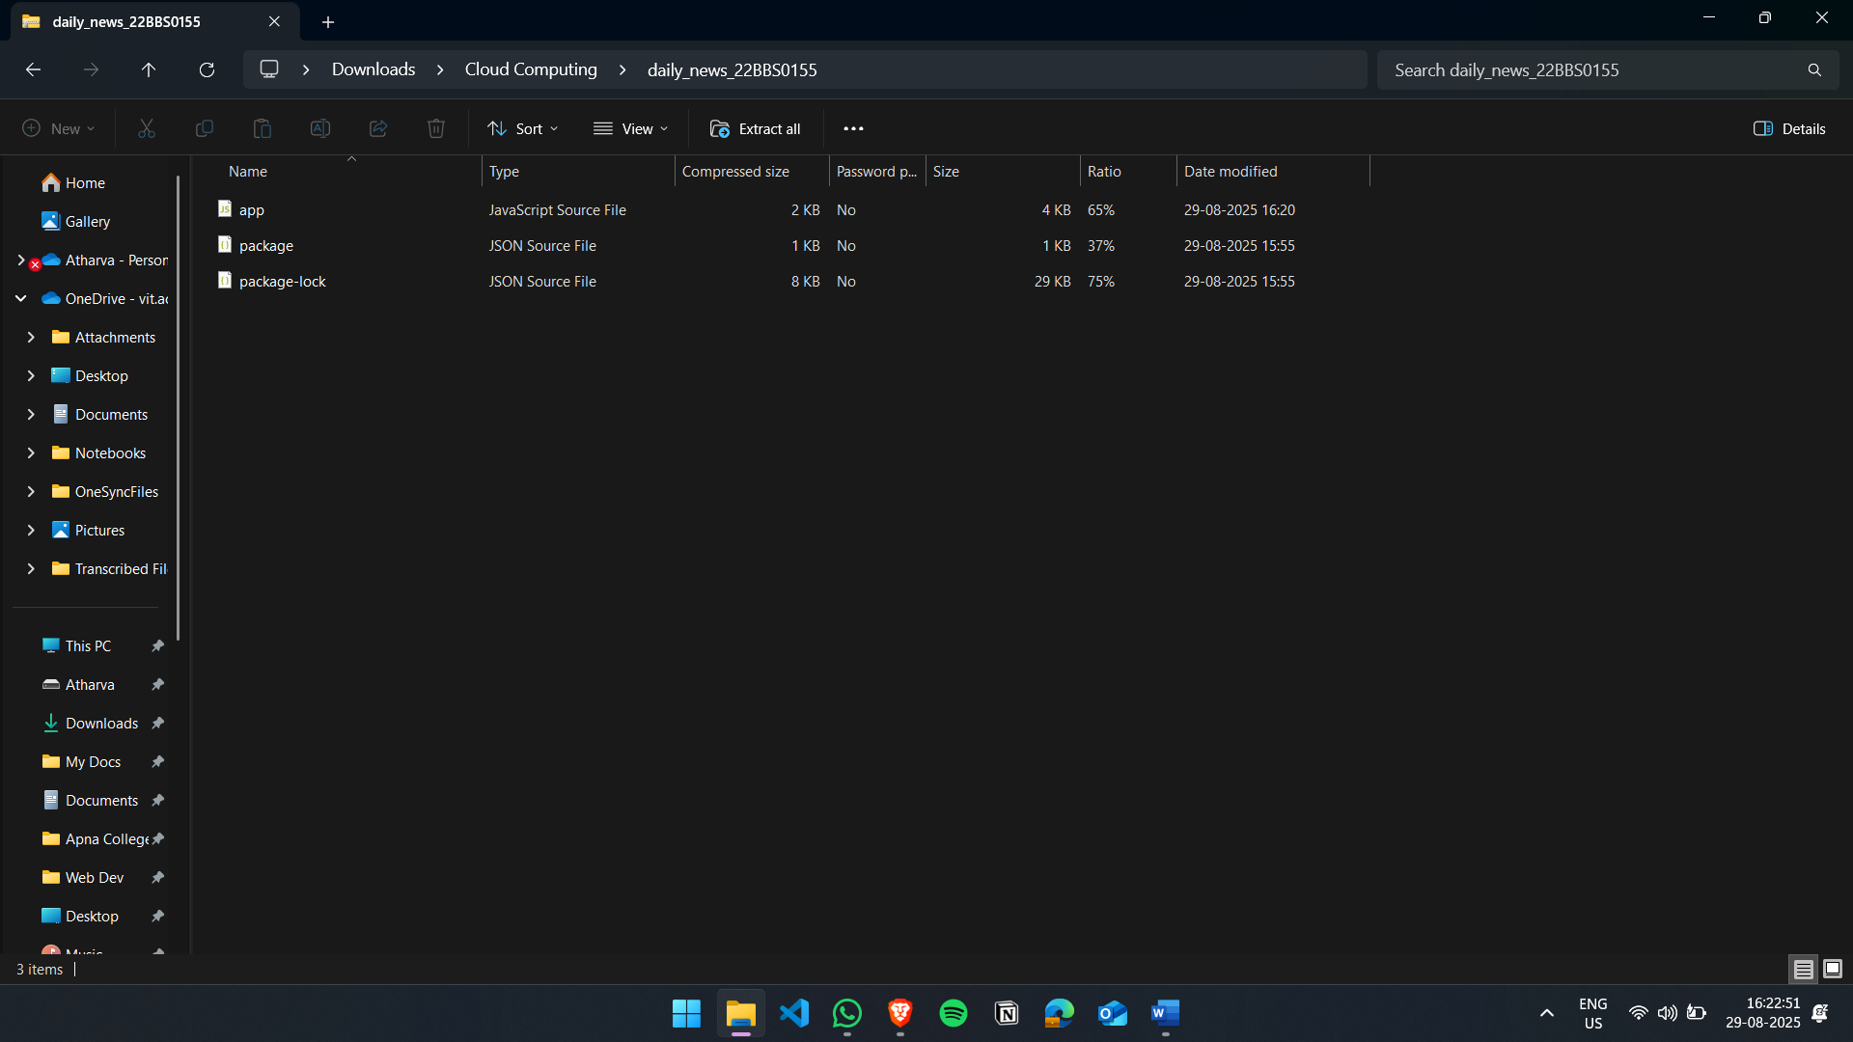

Create application on AWS Elastic Beanstalk
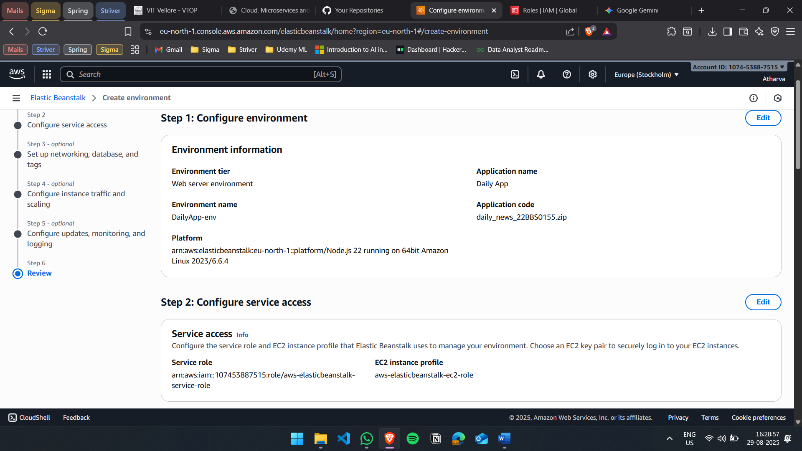

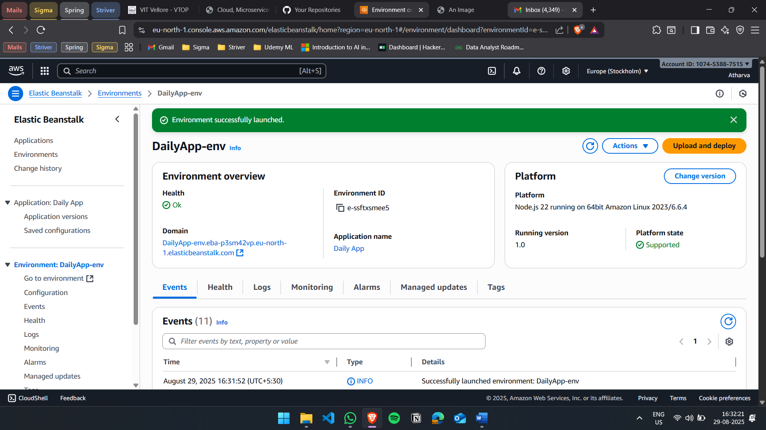

Access the application using the domain url
